Tiếng Anh 6 Unit 1 Towns and buildings

Tuần 5-Tiết 1 – 03-08/10/2022

Bài tập

I. Read the information about leeds. Then complete the email.

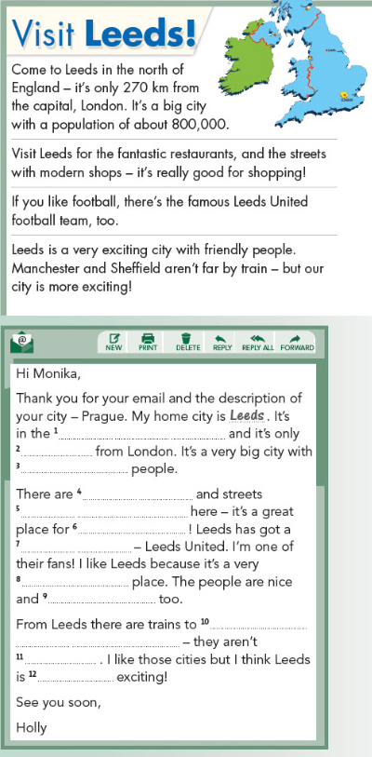

II. **Write an email to a friend about your city. Use the text in exercise 3 to help you.**